**Project 3 Part 4 (randomized approach average O(n))**

Name: Vivian Feng Period: 5

Date: 11/14/2022

Is your lab name l034?(lowercase L followed by digits 034) Yes

Did you created a class to store a point? Yes

Did you use a vector to store the points you read? Yes

Does your main contain only 2 calls of: part0(), part3() and part4() (NO part1/2!!)? Yes

(in main you may also have the part to display results for the 2 methods and them also in the txt file)

Obs: the part3 and part4 may have a return type like the time it took to complete the algorithm, the minimum distance, the points for the minimum distance, or you may create global variables for these.

Did you use an unordered map for your dictionary? Yes

Did you implement the Knuth algorithm to randomize the points? Yes

1. **Paste here a clear picture of the graph that compares the running times of the “full recursive” algorithm and “randomized” algorithm versus number of points. (use 2 different colors for the 2 graphs, colors that can be visible even if you print in black and white). Each point on this graph should be an average of several runs for that size:**

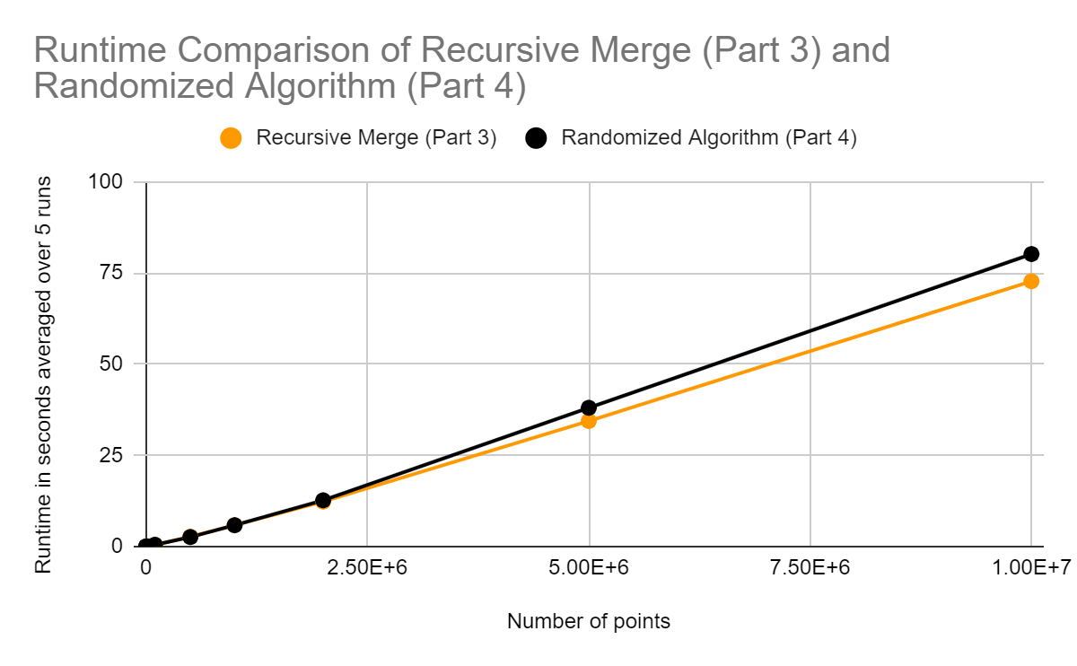

1. **Paste here the content of the results.txt when you run your lab on the content of the file points10k.txt and points100k.dat**

**For 10k:**

Merge sort method (Part 3)

Time taken: 66680 microseconds

Point 1: (0.50000000000000122124533,0.49999999999999977795540)

Point 2: (0.50000000000000122124533,0.49999999999999983346655)

Minimum Distance: 5.5511151231257827021182e-17

Randomized Algorithm (Part 4)

Time taken: 60568 microseconds

Point 1: (0.50000000000000088817842,0.49999999999999938937734)

Point 2: (0.50000000000000088817842,0.49999999999999944488849)

Minimum Distance: 5.5511151231257827021182e-17

**For 100k:**

Merge sort method (Part 3)

Time taken: 362081 microseconds

Point 1: (0.49999999999973127051689,0.49999999999889993551605)

Point 2: (0.49999999999975941467056,0.49999999999890892832255)

Minimum Distance: 2.9545963426100509438971e-14

Randomized Algorithm (Part 4)

Time taken: 325118 microseconds

Point 1: (0.49999999999975941467056,0.49999999999890892832255)

Point 2: (0.49999999999973127051689,0.49999999999889993551605)

Minimum Distance: 2.9545963426100509438971e-14